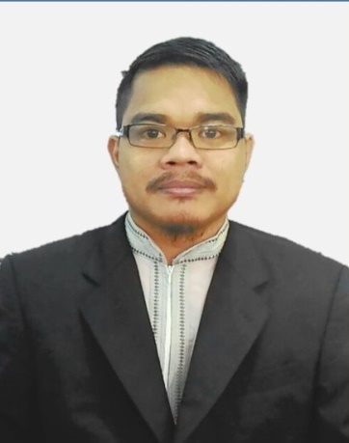









Studied management, accounting, strategy, marketing, operations, negotiation skill and about a hundred cases spanning all sectors.
UniKL- Malaysian Institute Info Tech (MIIT)
July 2007 – July 2011
Bachelor of Business Tecnology
In Computer Entrepreneur Management)
Courses in business technology entrepreneurial management including small business, management, technopreneurship, accounting, marketing, innovation management, operating system, information system, web-based, programming, imagination and creativity problem solving skills.
- Availability : 1 Month Notice
- Transport : Posses own transport.
- Preferred Work Location(s) : Johor
- Preferred Job Type(s) : Full-Time
- Expected Monthly Salary : MYR 3,800 (Negotiable)
- Job Specification : Senior Executive

JOB PREFERENCES
- Microsoft Words
- Microsoft Excel
- Microsoft Power Point
- Installation
- Backup and Recovery
- Format Pc and Laptop
- Windows XP,7,8,10
Technical
Management
COMPUTER SKILL
SMK Tengku Aris Bendahara Kluang Johor
2005 - 2006
Sijil Tinggi Pelajaran Malaysia

Sports Science
SMK Tengku Aris Bendahara Kluang Johor
2003 - 2004
Sijil Pelajaran Malaysia

Literature

1) Massumi Binti Madsnat, Head of Student Affairs, NMIT
Tel : 012-733 1082
2) Muhammad Syafie Bin Abdullah, Senior Executive Marketing, NMIT
Tel : 017-725 2159

Dec 2010 –Sept 2011
Administrative Executive (Student Affairs)
March 2015 - present
Netherlands Maritime Institute of Technology
To assist and responsible for managing students affairs department including admissions & records, welfare & services, sport & recreation and accommodations. Assisting Student Programme Manager to manage and organize activities and events accordingly. Proceed and processing of withdrawal application, warning letters, deferment application, termination and discipline records. Handling in student activity schedule, budgeting, transportation, proposal, and report. Attending to all students request (Letters and correspondences, referring to other department concerned).
Administrative Officer (Student Affairs)
August 2012 - Feb 2015
Kolej Teknologi Alpha
Ficronova Sdn Bhd
Internship/Part Time
Data entries, filling and other administration duties. To assist and responsible for managing students affairs department including accommodation, welfare and services. Manage all the accommodation parts including admissions and records, welfare and services, student discipline, maintenances and students complain. Create, handle, involved any activity for Alpha students and staffs especially in sport. Attend every top management meeting and help to make any solution and decision.

Reported to Engineer at Engineering Department. Performed Preventive Maintenance (PM) and Corrective Maintenance (CM). Troubleshoot desktop or notebook problem. Performed installation and testing.

EXTRA CURRICULUM
- Volunteer for Darul Ta’zim
- Volunteer for Iskandar Puteri Night Run
- Volunteer for Iskandar Puteri Challenge 2016
- Volunteer for Sundown run 2017
- Programme Manager (NMIT) Johor Future Run 2017
- Programme Manager (NMIT) for MASISWA Gamest 2017
- Athletic Track for MSSM (JOHOR)
- Football and Futsal player for MSSJ, UNIKL and NMIT

LANGUAGES
- Malay (Mother Tongue)
- English (good written good speech)

WORKING EXPERIENCE
__________________________________________
: No 03-10 Blok N, Pangsapuri Sri Lanang,
Jalan Harmonium, Taman Desa Tebrau
81100 Johor Bahru Johor

__________________________________________
: +6011 27557771
MOHAMAD FADLI BIN SHAFFAI @ SHAFIEI
REFERENCE
- Camping
- Hiking
- Volleyball
- Play Guitar
UniKL - Business School
EDUCATION
Sept 2011 –July 2013
Master in Business Administration
(Management)
you can also find me on :
__________________________________________
: fadli.shafiei@gmail.com
__________________________________________
: 25 July 1987

